TY Coffee Website – Sonas Coffee
Our Story
Thanks to the generous support of our sponsor, our school was able to purchase a brand-new coffee machine — giving our Transition Year students the exciting opportunity to learn real barista skills! From brewing the perfect espresso to mastering latte art, this hands-on experience lets students explore the world of coffee making while gaining valuable life and workplace skills.

Coffee Types:
- Americano
- Cappuccino
- Latte
- Flat White

Prices
Teachers can purchase a coffee card for four coffees for €10. With this teacher’s get their 5th Coffee Free!

Facilities
- Sage Coffee Machine
- Milk Frother

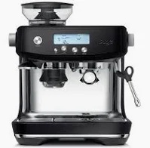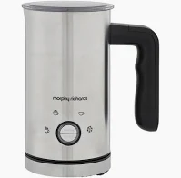

Open Hours:
Day | Time
Monday | 8.30 – 8.50
Friday | 8.30 – 8.50

Where can you find us?

